**Unit: Manual Motor Controls Test: 3**

**NEMA Symbols and Basic Motor Controls CLO#: 1**

Name ______________________________ Date ______________

**Instructions**

Fill in the description and I/O columns for each NEMA schematic symbol below.

|  | Symbol | Description | I/O |
| --- | --- | --- | --- |
| 1 |  |  |  |
| 2 |  |  |  |
| 3 |  |  |  |
| 4 |  |  |  |

|  | Symbol | Description | I/O |
| --- | --- | --- | --- |
| 5 |  |  |  |
| 6 |  |  |  |
| 7 |  |  |  |
| 8 |  |  |  |
| 9 |  |  |  |
| 10 |  |  |  |
| 11 |  |  |  |
| 12 |  |  |  |
| 13 |  |  |  |
| 14 |  |  |  |
| 15 |  |  |  |
| 16 |  |  |  |
| 17 |  |  |  |
| 18 |  |  |  |
| 19 |  |  |  |
| 20 |  |  |  |
| 21 |  |  |  |
| 22 |  |  |  |
| 23 |  |  |  |
| 24 |  |  |  |
| 25 |  |  |  |

|  |  |  |
| --- | --- | --- |
| Pushbutton, Normally Open | Selector Switch, Three Position | Temperature Switch, NO |
| Pushbutton, Normally Closed | Switch, Normally Open | Temperature Switch, NC |
| Pushbutton, Dual Action | Switch, Normally Closed | Limit Switch, Normally Open Held Closed |
| Pilot Light | Limit Switch, Normally Open | Limit Switch, Normally Closed Held Open |
| Pilot Light, Green | Limit Switch, Normally Closed | Foot Switch, Normally Open Held Closed |
| Contacts, Normally Open | Float Switch, Normally Open | Foot Switch, Normally Closed Held Open |
| Contacts, Normally Closed | Float Switch, Normally Closed |  |
| Coil | Flow Switch, Normally Open |  |
| Pushbutton, Mushroom Head | Flow Switch, Normally Closed |  |
| Selector Switch | Pressure Switch, Normally Open |  |
| Selector Switch, Two Position, Dual Action | Pressure Switch, Normally Closed |  |

1. Select all the correct terms used to describe the state of a component that is not wired within a circuit.
   1. Normal
   2. Made
   3. Shelf
   4. Switched
2. Match the parts of the clapper relay.

|  |  |  |
| --- | --- | --- |
|  | A. | Normally Closed Contact |
| B. | Moveable Contact |
| C. | Armature |
| D. | Coil |
| E. | Normally Open Contact |

1. A component (pushbutton, selector switch) that is normally open would have terminal numbers ____ and ____.
2. If a circuit has four inputs, in how many possible states can that circuit be placed?
3. When hand drawing a control schematic, wire numbers are denoted by using?
   1. Boxes
   2. Triangles
   3. Circles
   4. Underline
4. When hand drawing a control schematic, terminal numbers are denoted by using?
   1. Boxes
   2. Triangles
   3. Circles
   4. Underline

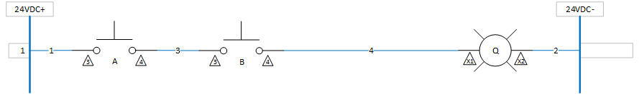

1. Draw a truth table for, show the formula and give the name for the above circuit.
2. The purpose of the circuit below is to start and stop a motor with lights to indicate that state of the motor (green running, red stopped)? Will this circuit works as designed? Why or why not?

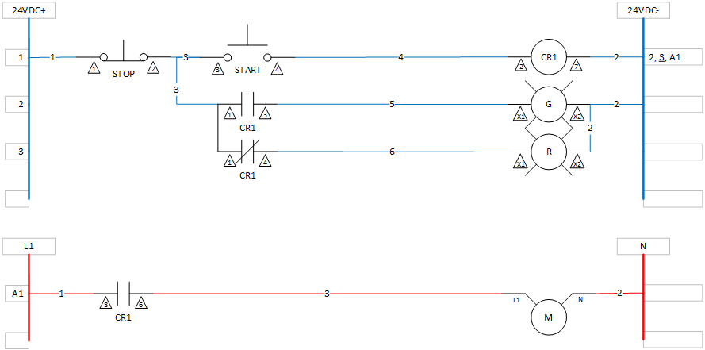

1. Mark up the drawing below to fix items that are incorrect or omitted.

